Bug report

Bug ID: Instabug_Monefy_bug_01 | Module: Instabug_Monefy_Home_022
Status: Opened | Bug type: Functionality
Environment: android mobile | Severity: low
Bug Title: the design of balance button is bad with big number on it

Test steps:

1-open “money” app
2-enter a low income
3- enter a high expense
4- see the design of the balance number

Expected result : the balance square must be suitable

Actual result : the balance design button is bad

Screen shots:

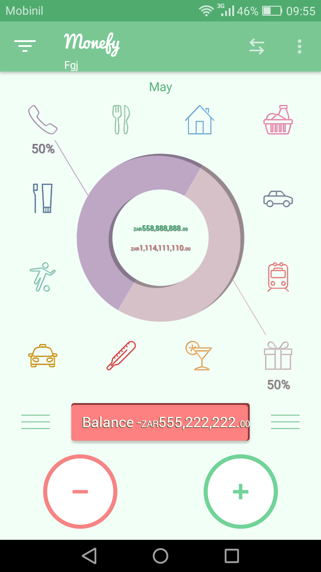

Bug ID: Instabug_Monefy_bug_02 | Module: Instabug_Monefy_Home_027
Status: Opened | Bug type: Design
Environment: android app | Severity: Trivial
Bug Title: icon shape isn’t descriptive

Test steps:

1-open “monefy” app

Expected result : all symbols describe what it have

Actual result : the top left menu can be improve with a descriptive symbol like clock

Screen shot

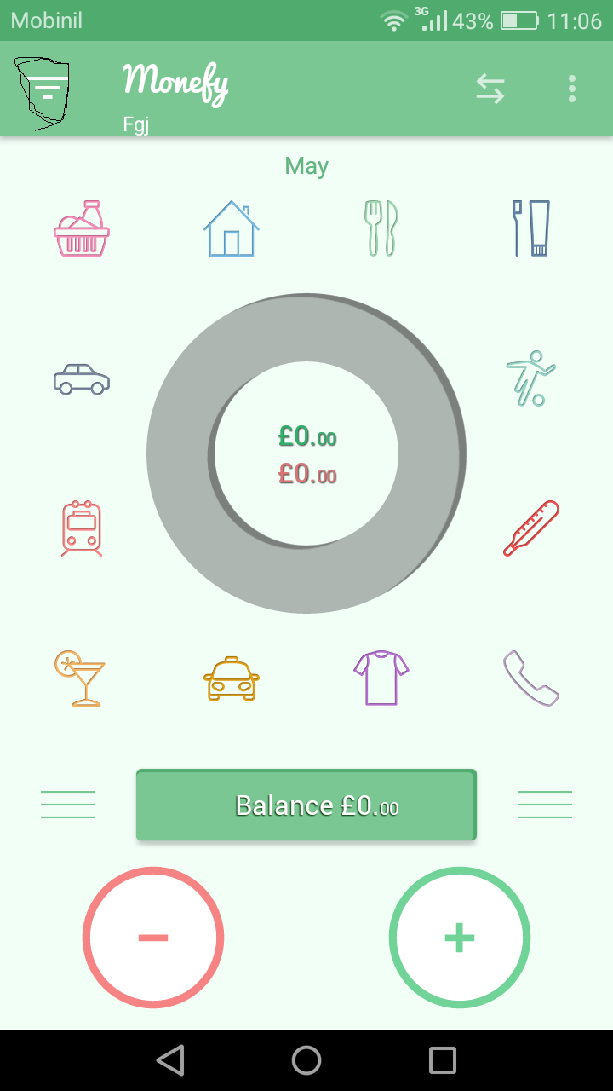

Bug ID: Instabug_Monefy_bug_03 | Module: Instabug_Monefy_Income_008
Status: Opened | Bug type: functional
Environment: android app | Severity: low
Bug Title: the operational symbols doesn’t appear while using it

Test steps:

1-open “monefy” app
2-click on “income ” button
3-enter a first number
4- click “+”
5-enter a second number

Expected result : user should see”+” on the screen to know that he added it

Actual result : he add successfully but add symbol doesn’t show on the screen

Bug ID: Instabug_Monefy_bug_04 | Module: Instabug_Monefy_Transfer_003
Status: Opened | Bug type: functional
Environment: android app | Severity: Major
Bug Title: allow change from cash to visa with no Credit in cash

Test steps:

1-open “monefy” app
2-click on “transfer ” button
3- transfer from cash to visa

Expected result : user should see error that there is no cash to transfer

Actual result : he add successfully the transfer

Screen shots :

There is 0 cash and it transfer 10000 normally

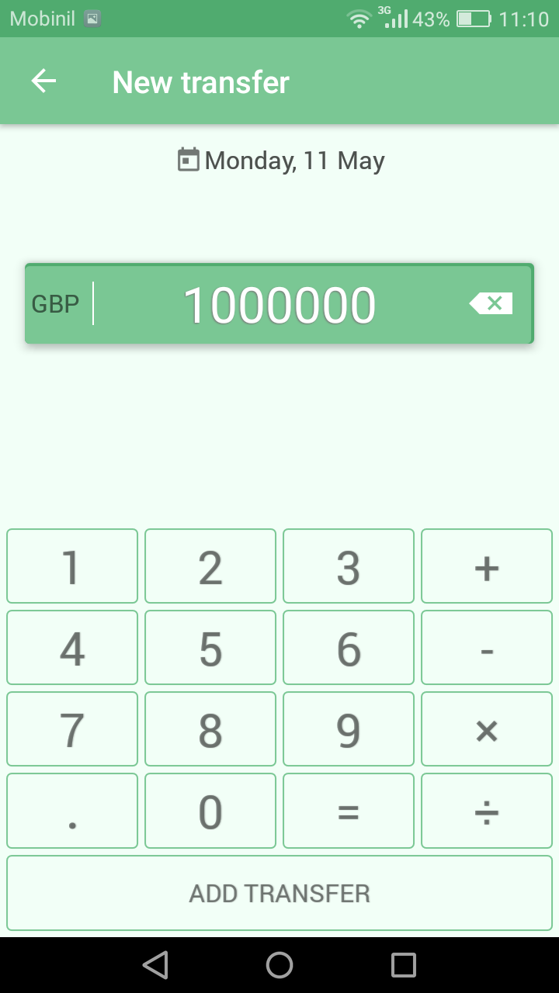

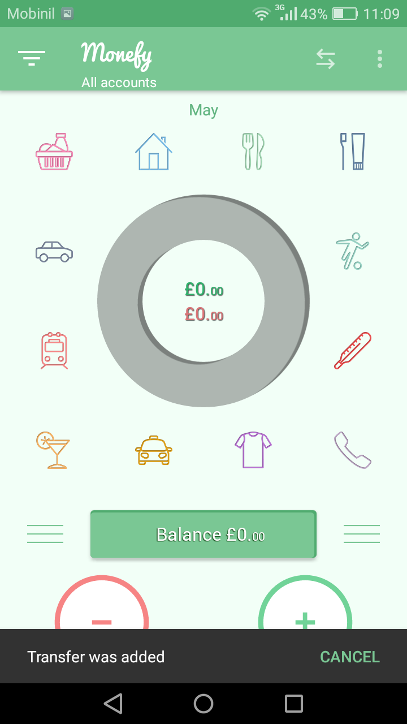

Bug ID: Instabug_Monefy_bug_05 | Module: Instabug_Monefy_setting_004
Status: Opened | Bug type: Functionality
Environment: android mobile | Severity: Minor
Bug Title the currency doesn’t change while changing the language

Test steps:

1-open “monefy” app
2-click on “menu ” button in the top right
3- click on “setting”
4- click on “language”
5-choose a language

Expected result : the currency should be changed to The official currency of the selected country

Actual result : the currency doesn’t change

Screen shots:

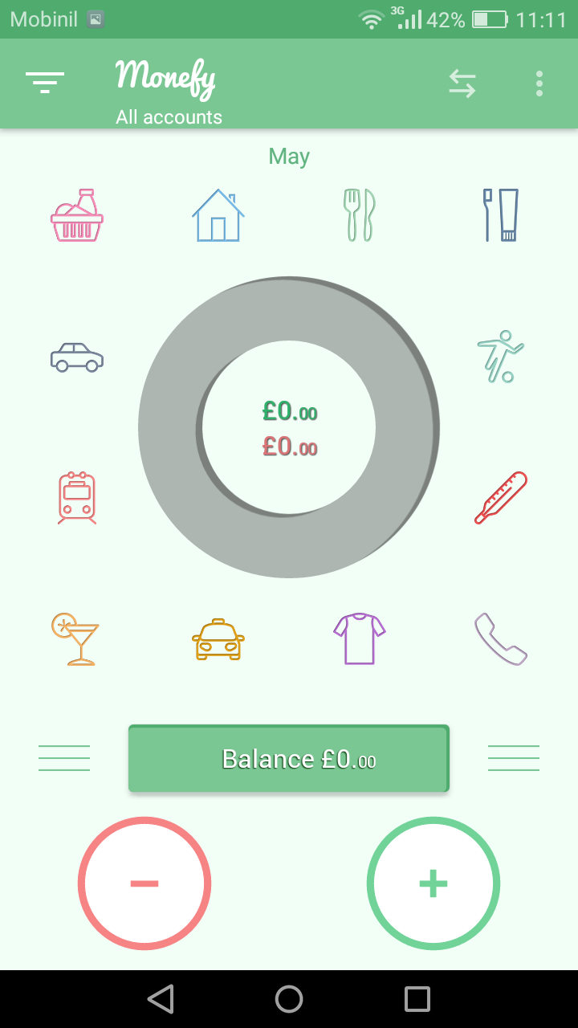

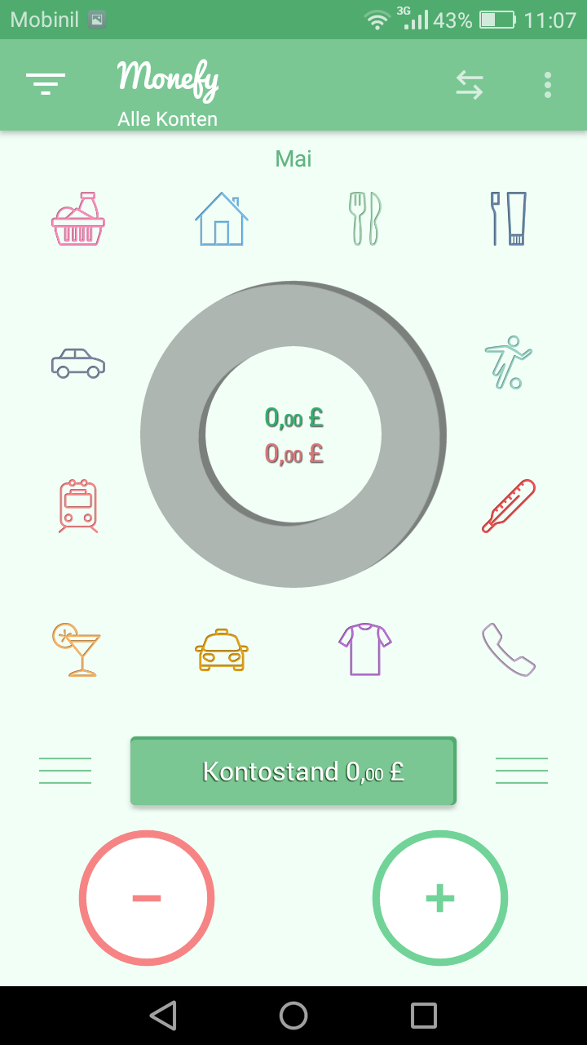

I changed the language to Dutch but the currency still the same

Bug ID: Instabug_Monefy_bug_06 | Module: Instabug_Monefy_setting_005
Status: Opened | Bug type: Functionality
Environment: android mobile | Severity: low
Bug Title The languages aren’t arranged in alphabetical order

Test steps:

1-open “monefy” app
2-click on “menu ” button in the top right
3- click on “setting”
4- click on “language”

Expected result : The languages are arranged in alphabetical order

Actual result : The languages are not arranged in alphabetical order

Screen shot:

